BÁO CÁO THỰC HÀNH LAB 1

BỘ MÔN : LẬP TRÌNH HƯỚNG ĐỐI TƯỢNG -2022.2

Họ tên: Trần Như Thái

MSSV : 20194835

The very first Java program:

2.2.1. Write and compile the first Java application

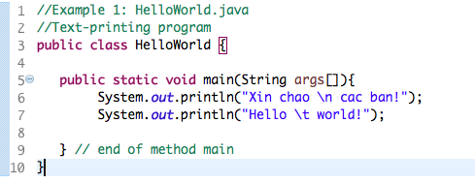

Kết quả:

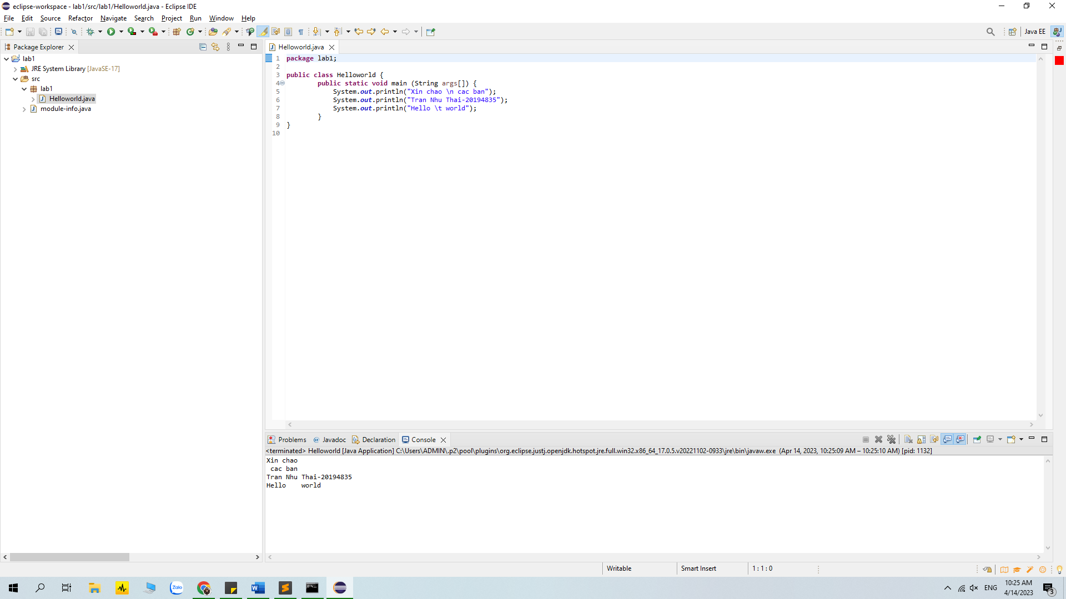

2.2.2 Write, compile the first dialog Java program

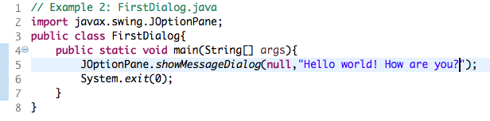

Result:

## 2.2.3 Write, compile the first input dialog Java application

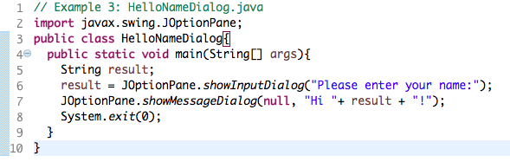

Result:

## 2.2.4 Write, compile, and run the following example:

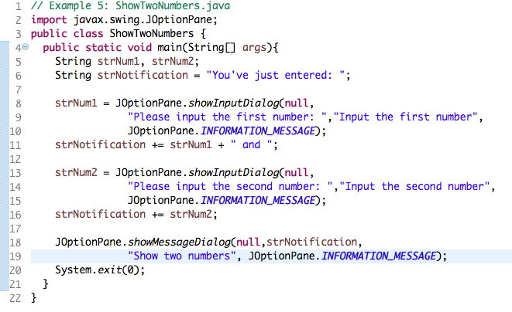

Result:

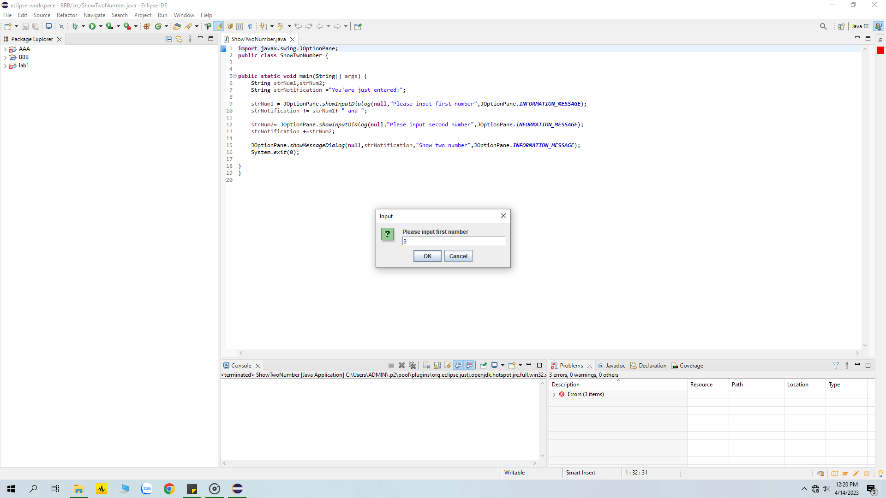

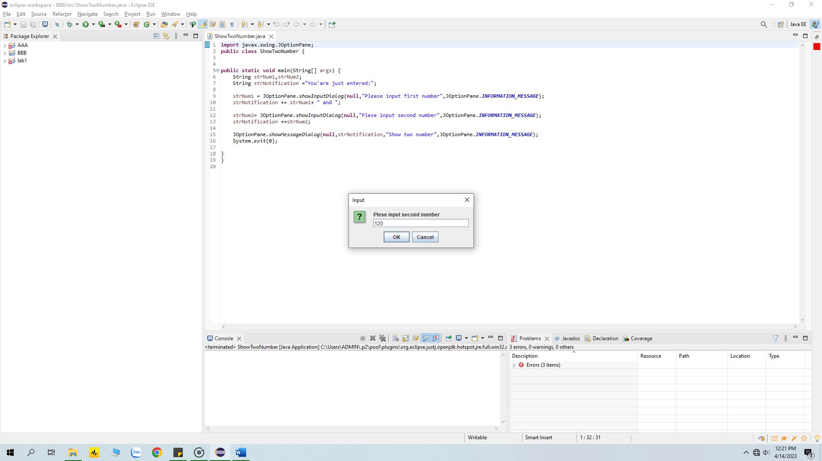

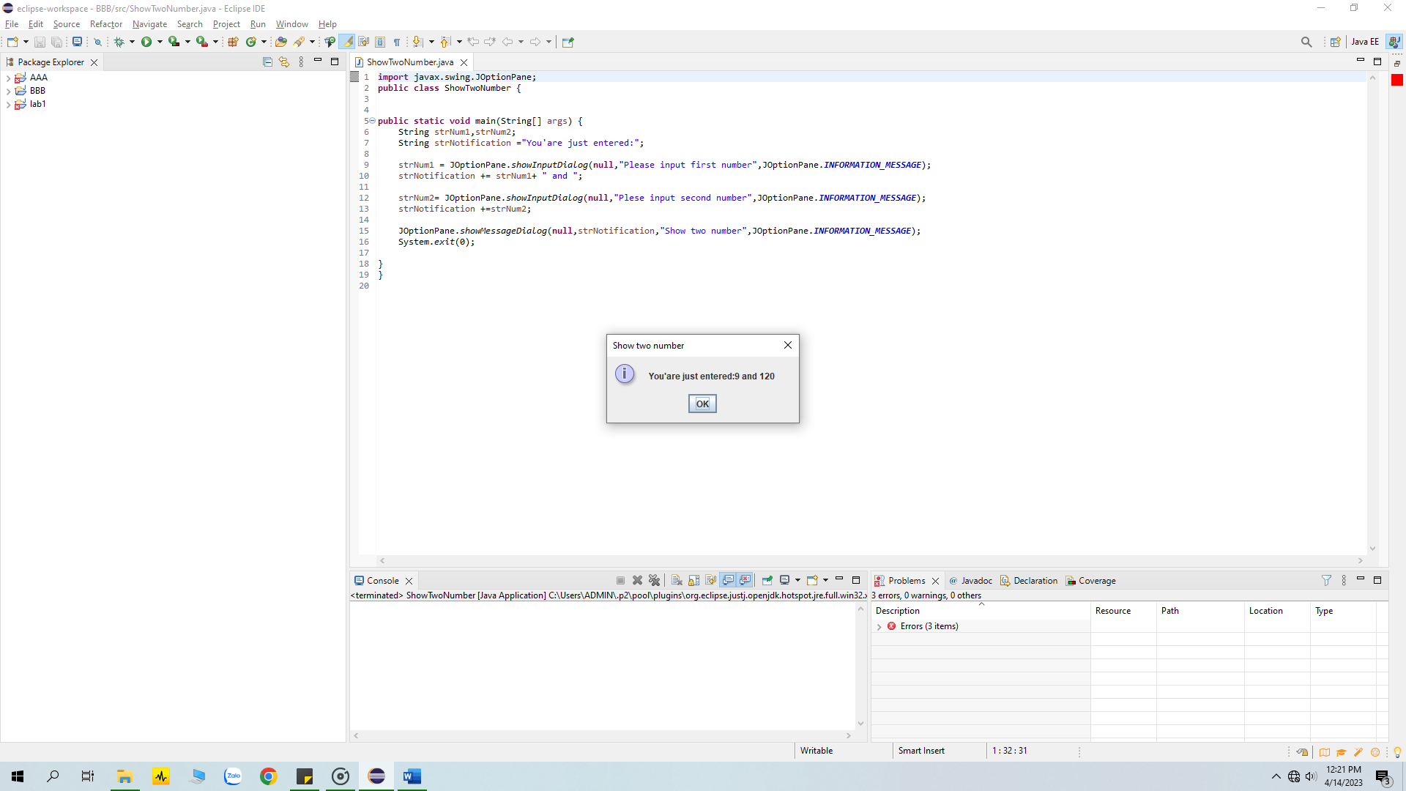

## 2.2.5 Write a program to calculate sum, difference, product, and quotient of 2 double numbers which are entered by users.

## Result:

## 

2.2.6. Write a program to solve

+) first degree equation with one variable

Result:

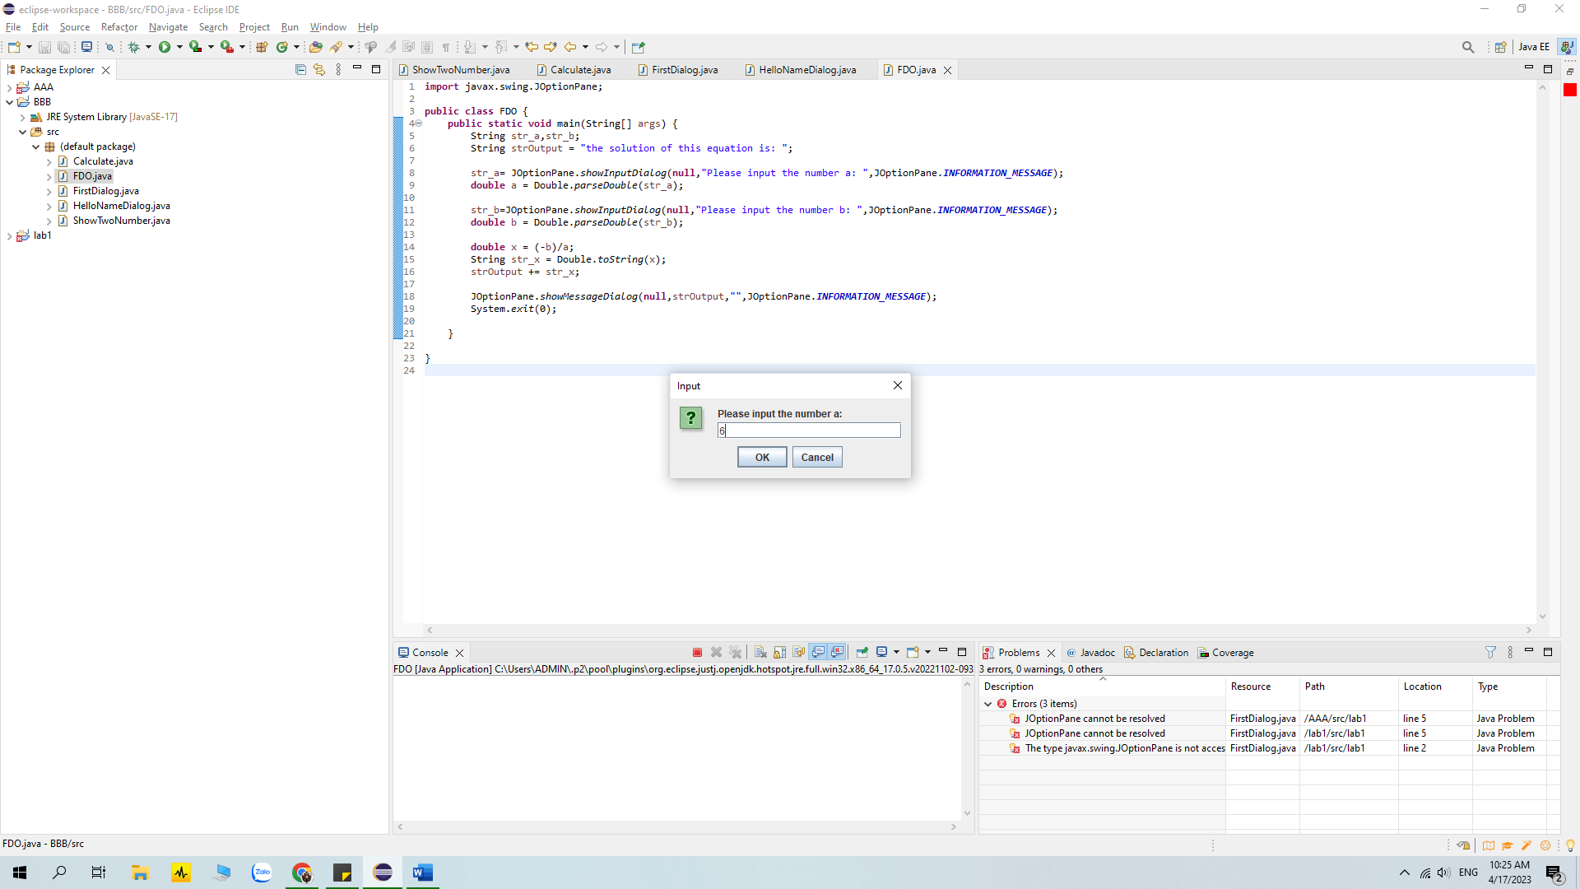

+) first degree equation with two variable

Result:

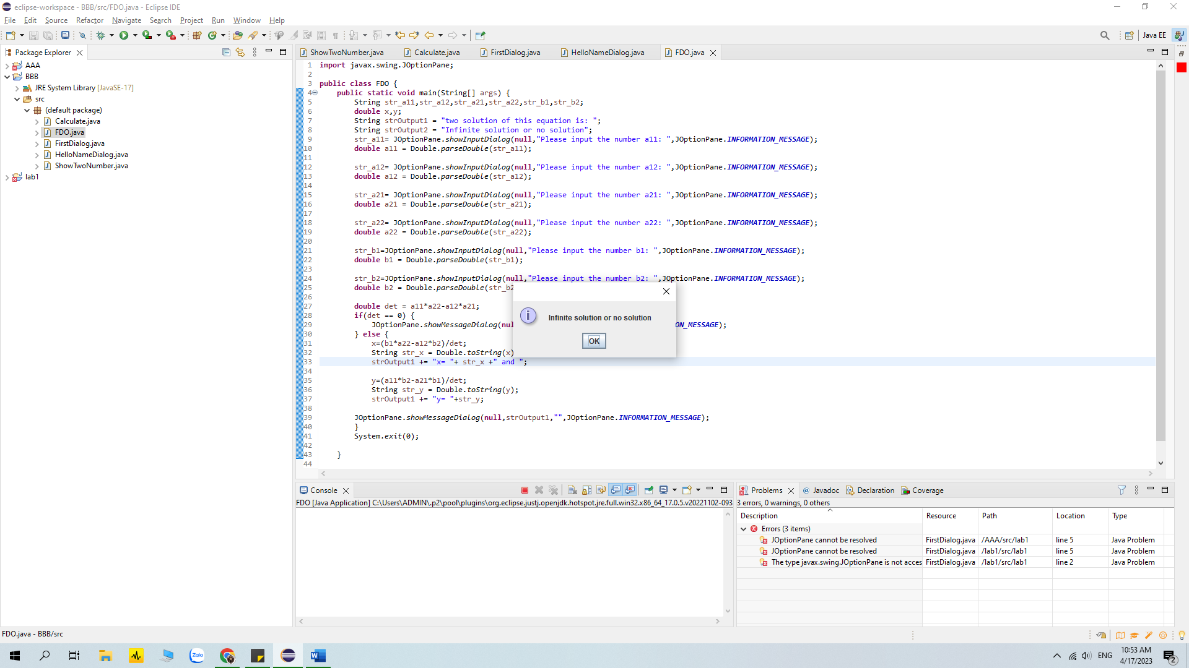

+) second degree equation with one variable

Result:

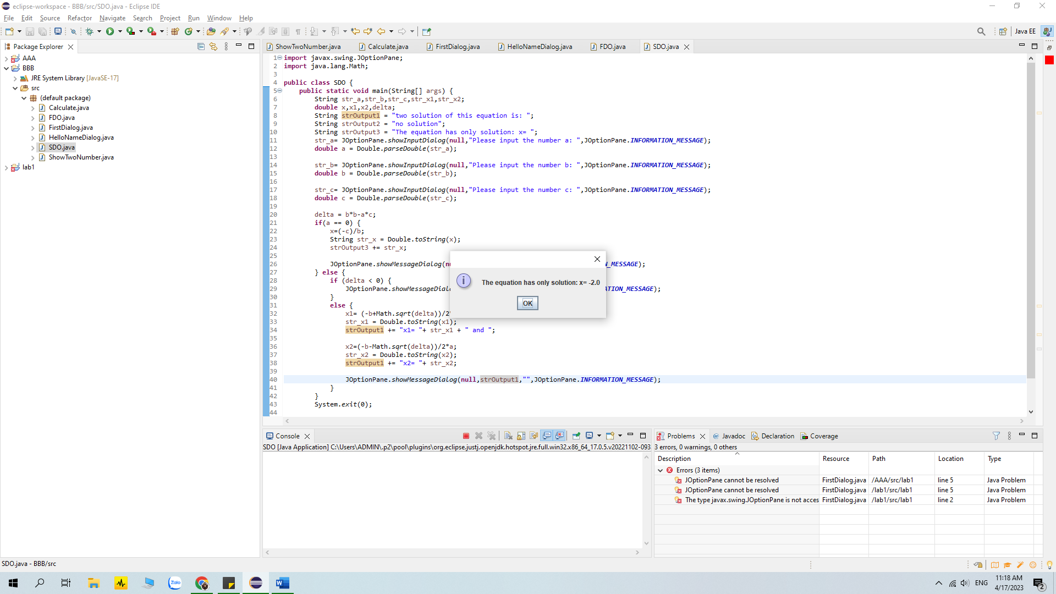

6.1 Write, compile and run the ChoosingOption program:

Result:

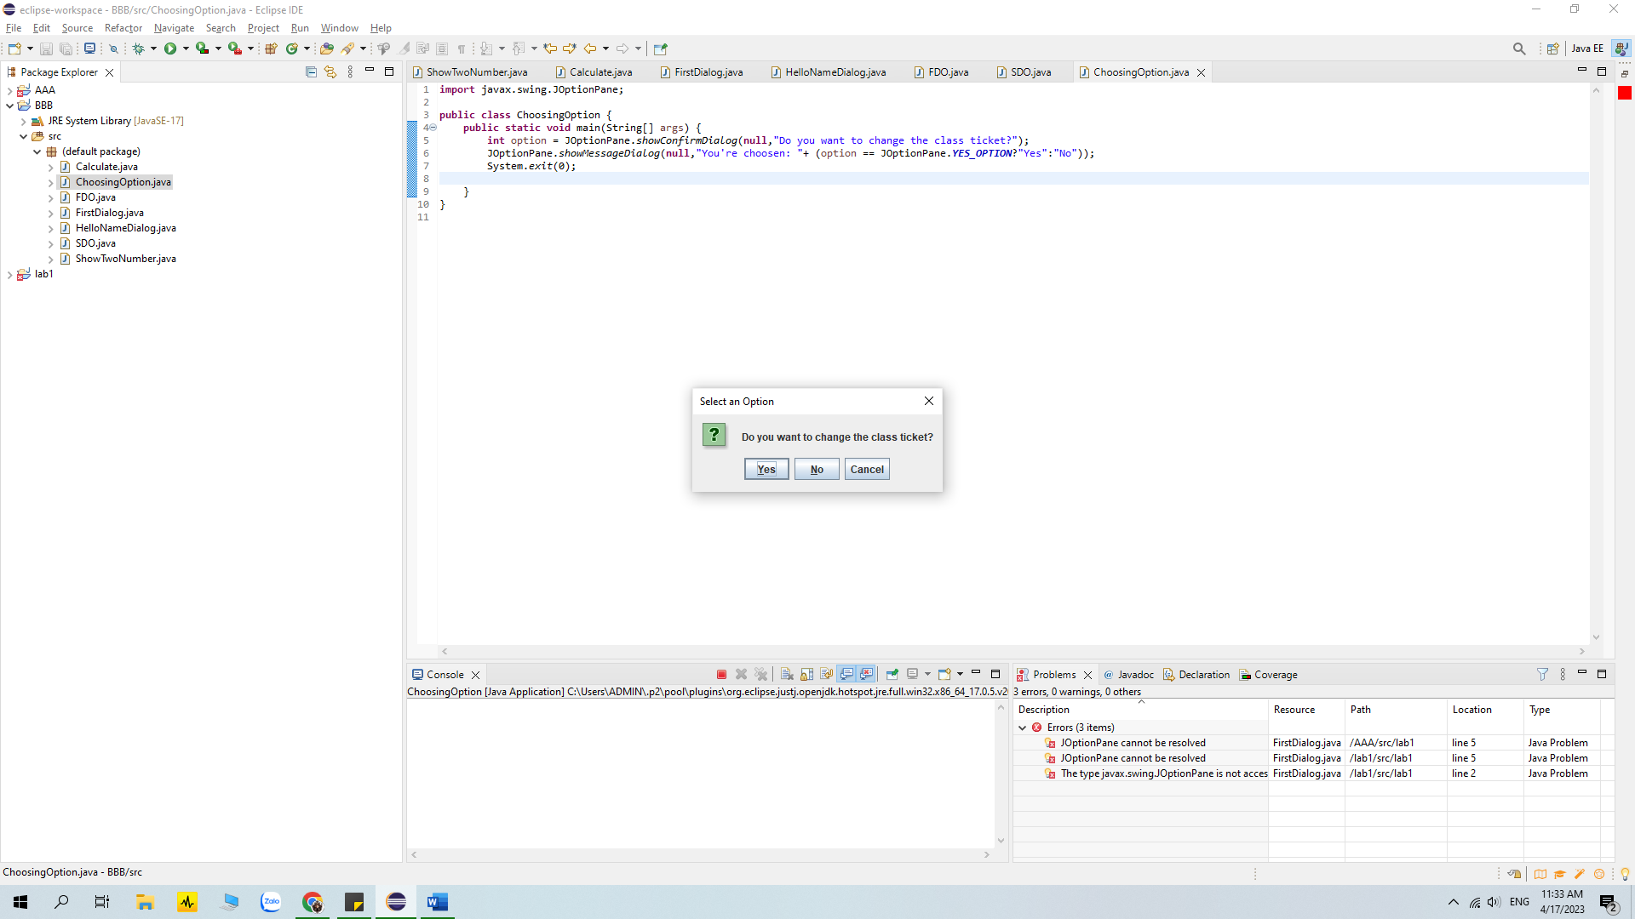

6.2 Write a program for input/output from keyboard

Result:

6.3 Write a program to display a triangle with a height of n stars (*), n is entered by users.

Result:

6.4 Write a program to display the number of days of a month, which is entered by users

(both month and year). If it is an invalid month/year, ask the user to enter again.

Result:

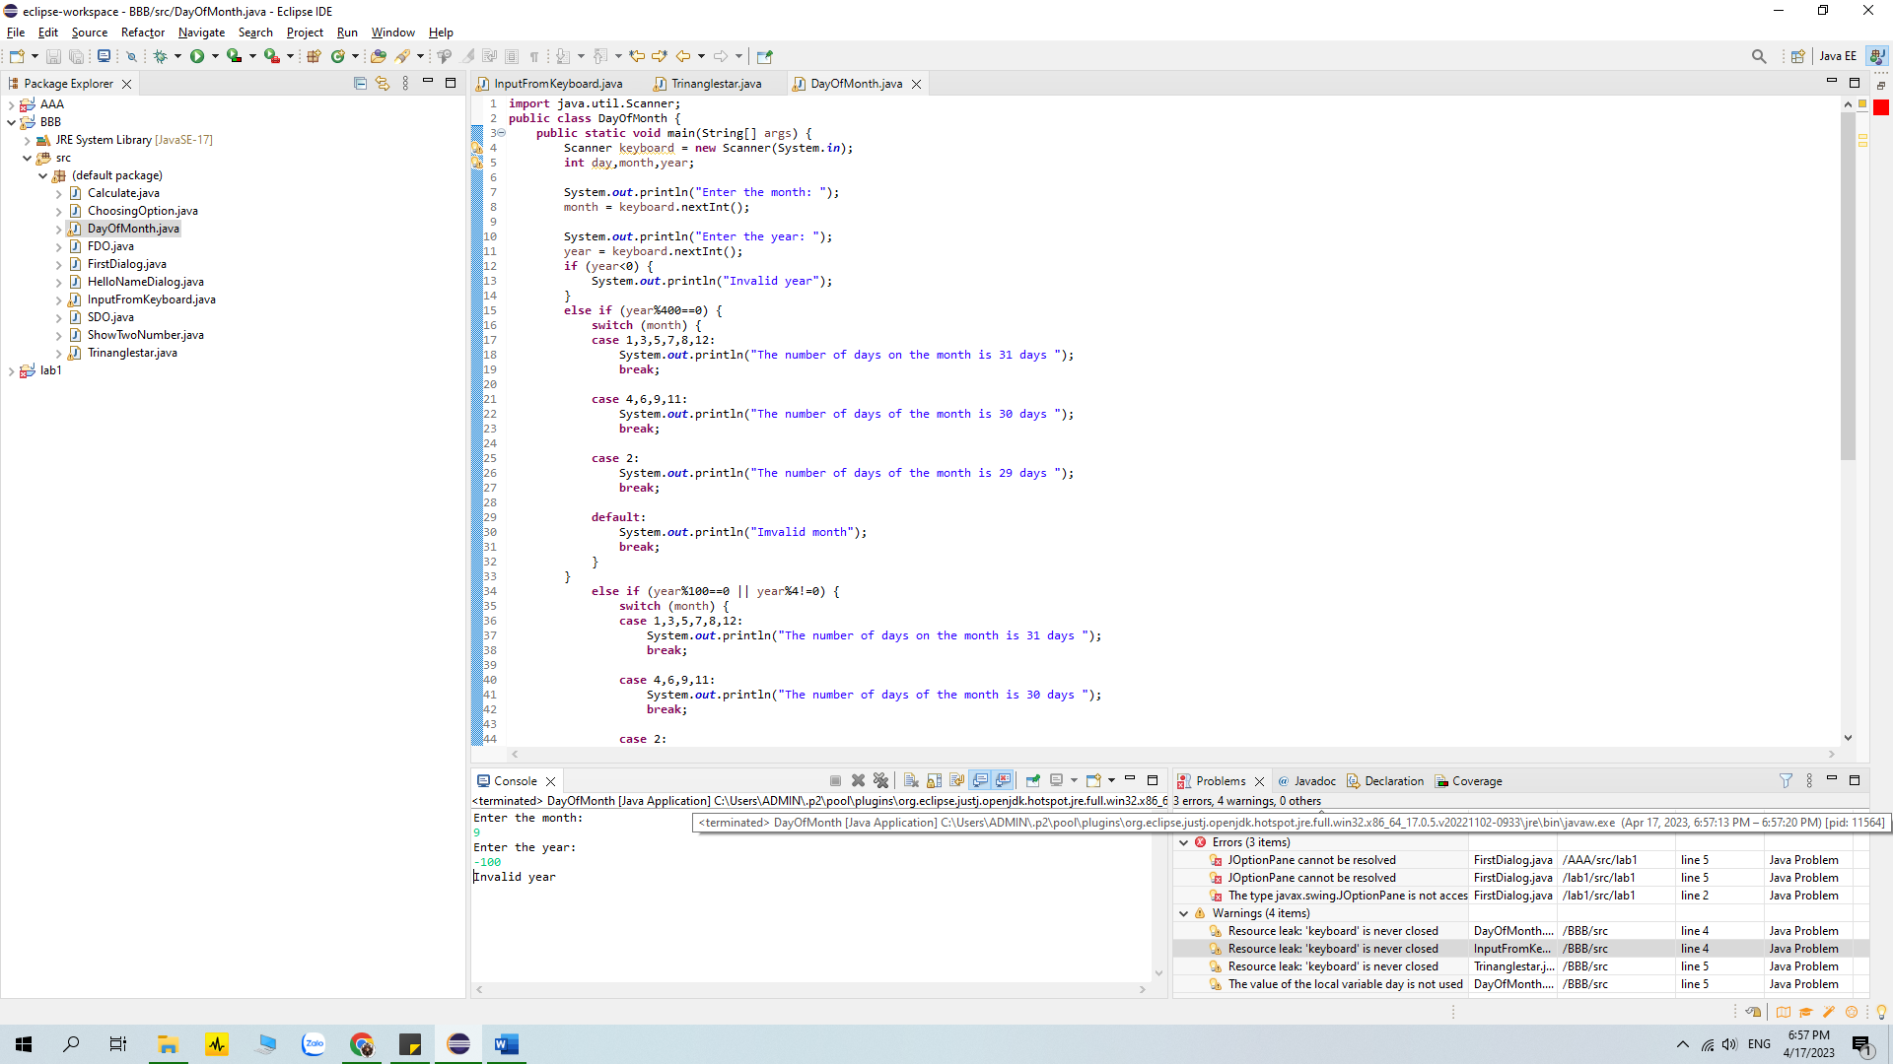

6.5 Write a Java program to sort a numeric array, and calculate the sum and average value of array elements.

Result:

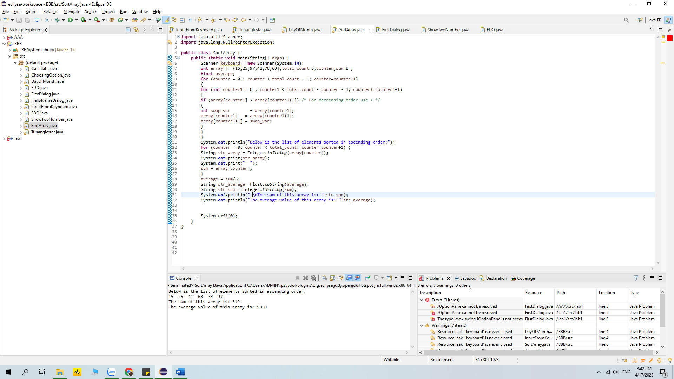

6.6 Write a Java program to add two matrices of the same size.

Result:

